**Project Design Phase-I**

**Solution Architecture**

|  |  |
| --- | --- |
| Date | 19 September 2022 |
| Team ID | PNT2022TMID44838 |
| Project Name | Retail Store Stock Inventory Analytics |
| Maximum Marks | 4 Marks |

**Solution Architecture:**

Solution architecture is a complex process – with many sub-processes – that bridges the gap between business problems and technology solutions. Its goals are to:

* Find the best tech solution to solve existing business problems.
* Describe the structure, characteristics, behavior, and other aspects of the software to project stakeholders.
* Define features, development phases, and solution requirements.

Provide specifications according to which the solution is defined, managed, and delivered.

**Solution Architecture Diagram:** 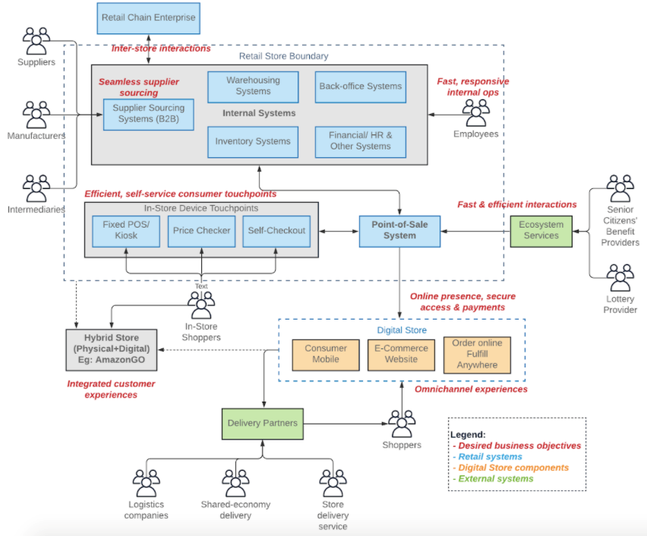

Figure 1: Architecture and flow diagram of the retail store stock inventory analytics

To make this retail store possible, different retail components like point-of-sale systems, inventory management, warehousing, sourcing, and in-store devices have to work together. However, it is not currently designed to achieve the business architecture or objectives set out in section as there are several challenges. For instance, the systems may have been acquired at different points in time, and may not be connected to achieve the desired objectives.

* The applications/ components that are existing in a particular retailer store are shown in blue.
* The external partner systems are shown in green, which may or may not connect to the retail store systems.
* The online stores are depicted in orange.
* The text in red shows the objectives that the retailer wants to achieve in the future through each component.
* The hybrid store in grey shows a potential farfetched objective for the business. It may have its own or a combination of technology/ systems.
* Any component in the diagram may or may not be present at a retailer at any given time.

The common problem with these types of application architectures is that systems are from various vendors that adopt heterogeneous technologies and standards. Retailers must connect them to solve certain challenges like offering seamless omnichannel experiences and opening up new online revenue options. Sometimes, the applications are designed to work in isolation and it results in data silos. The underlying connective technology plays a significant role in achieving the objectives through business architecture. We use this opportunity and challenges as the basis for proposing the desired technical architecture for a retail chain in the next section.